1.Introduction

Dataset
Our dataset contains information from several different outlets regarding product information and sales information. It concerns information about items regarding their fat content and weight, together with information about the outlet concerning year of establishment, size, and location type. The dataset also includes sales, rating of the products and the visibility of the products. In combination, the variables give a good understanding of how sales are affected by product factors and store factors.

Identified problem
It is often a major problem to understand which product factors and store factors affect sales the most. It is important to understand what affects sales the most because it provides an opportunity for better inventory management and allows one to display the products in the store that have the highest sales value. The products with the highest sales value can be identified using various visual elements, such as bar charts, tables, matrices, and slicers.

Objectives
There are many different objectives that can be achieved through the data. One objective that can be analyzed is how sales are affected by product factors regarding fat content, weight, and item type, for example, bread and fruits and vegetables. Another objective could be to see the effect on sales regarding store characteristics such as location, year of establishment, and size. It is also possible to analyze which products sell the most depending on how visible they are in the store, the weight of the product, and the fat content of the product.

Dataset description
Below follows a description of our assigned dataset.
Item fat content describes the amount of fat content a product contains; it concerns regular and low fat.
Item identifier indicates that each product has a unique identification.
Item type describes which product category it belongs to, for example, fruits and vegetables, frozen food, bread, meat, and soft drinks.
Outlet establishment year presents the year the store was established, from 2011 to 2022.
Outlet identifier indicates that each store has a unique identification.
Outlet locations type concerns the location of the store; it is either tier 1, tier 2, or tier 3.
Outlet size refers to the size category of the store. The store can be small, medium, or high.
Outlet type describes which store category it belongs to, for example, grocery store or supermarket.
Item visibility presents the visibility of the product in the store.
Item weight indicates the weight of a product.

Data modeling

Data enrichment
The data that was given had some errors that needed to be fixed. The first step was to fix issues with the “item fat content” column. It was noticed that there were different synonyms that made the data look unclear. Some values were changed, for example “LF” to “Low Fat”, “low fat” to “Low Fat” and “rg” was changed to “Regular”. When this was adjusted, another error was noticed in the data. A large amount of values in the “Item Weight” column was set as “null”. After confirming with Nitin, the decision was made to put these values as the median, which resulted in 12.6.

2.2 Star Schema
In the beginning, an attempt of a star schema was made from making a new table with outlet data. This was done by combining “Outlet Identifier”, “Outlet Type”, “Outlet Establishment Year”, “Outlet Location Type” and “Outlet Size”. All the duplicates were also removed to improve filtering. After that, another table was formatted combining “Item Fat Content”. “Item Identifier”, “Item Type”, “Item Visibility” and “Item Weight”. An attempt was made to connect these new tables as a star schema to the Grocery Data. But multiple errors occurred, and it was then decided to not use a star since the data in the original table was clear enough.

2.3 DAX
The measures created were “Total Sales – Low Fat” and “Total Sales – Regular.” These measures calculate total sales, focusing on low-fat products in one and regular products in the other. This helps compare the sales of products with different fat levels, which is illustrated in a donut chart in figure 4.
A third measure was created to show the percentage of total sales for each item type, giving a clearer understanding of how each item type contributes to the total sales. This measure can be seen in use in the third column of the matrix, which is located on top left in figure 4.
For figure 1 the Average function was used to get the data of average sales. In combination with a card on the dashboard, this enabled a clear visual of how the average sales varied item types, outlet location, outlet types and outlet size.
In figure 1, to show KPI-values over trends of different item types, outlet location, outlet types and outlet size. Since the data didn’t include any sales goals, to allow the KPI to assess the performance of a selected segment against a constant benchmark that ignores all the filters, a measure was created. Average sales were put in value, and the trend line is based on the outlet establishment year. If the KPI shows as negative, it means that a specific item is performing worse than the average global sales and vice versa.

Dashboards
The dashboard Figure 1 presents an analysis of grocery store sales data. It highlights essential data like total sales as well as average sales. A pie chart is used to visualize these metrics, which gives a clear overview of how different item types perform both through revenue and percentage. Below the pie chart, a matrix gives a quick rundown of how each outlet type is performing. The dashboard also illustrates KPIs that make it easy to track trends of different item types compared to the global benchmark. By utilizing slicers, the data can be filtered by item type and store type. The dropdown menu in the Store type & Location slicer gives further options allowing more filtering by tier and outlet size. When choosing different combinations, the visualizations update in real time which enables both simple and advanced comparison.
Figure 1 Grocery Sales Performance Overview
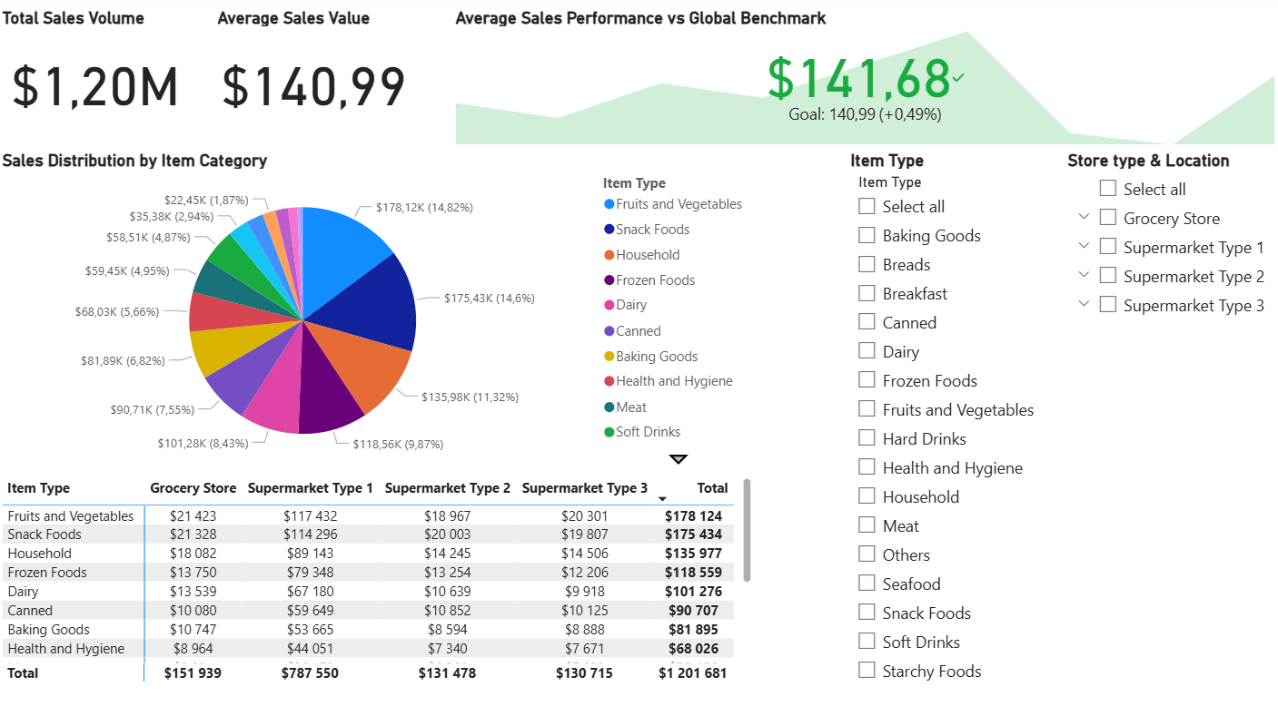
Sum of Sales by Item Type: Here you can clearly see which item type contribute the most to sum of sales. The item type that sells the most is fruits and vegetables, followed by snack foods and household.
Sum of Sales by Outlet Size: You can see which outlet size contributes the most to sales. The store size that generates the most sales is classified as medium.
Count of Item Type by Item Fat Content: This shows the fat content of different item types. You can see that there are more products with low fat content than regular fat content.
Use of slicers for item type: Slicers make it clear and easy to analyze only one item type, for example, if you want to see whether an item type contains low fat or regular or if you want to see how much sales an item type generates.
Outlet Type / Item Type / Sum of Sales (matrix):
By creating a matrix of these, you can see which combinations of outlet type and item type contribute the most to total sales. By adding up all products per row, you can see which outlet type contributes the most to sales. In this case, it is Supermarket Type1.
By using a card visual you can see that the sum of sales are 1,20 million.
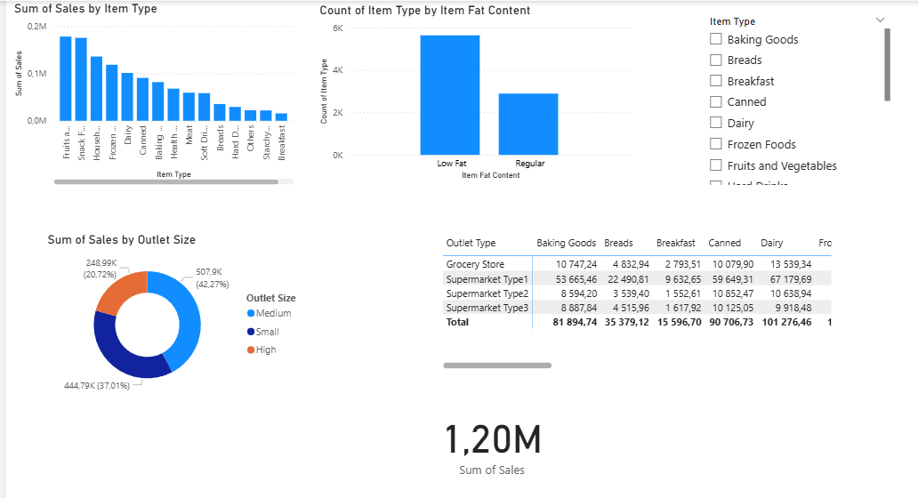
Figure 3 Sales and Item Performance
This Dashboard provides a clear overview of sales, products and customer satisfaction. The Total Sales (1.20mn) card visual gives a quick view of the total amount sold. The bar chart showing Item Weight by Fat Content and Outlet size highlights how Low Fat and Regular items vary depending on whether the outlet is small, medium or large. The pie chart visualizes Item Visibility by Item Type, showing categories such as Fruits & Vegetables, Snack Foods and Frozen Foods are most visible in the dataset. This is connected to the rating table, which shows that the categories with the highest visibility also receive the highest ratings, making them top performing items. This tells us that visibility is connected to customer satisfaction. The year slicer allows users to filter results by outlet establishment year (the year each store was opened), making it easier to compare performance between older and newer outlets.
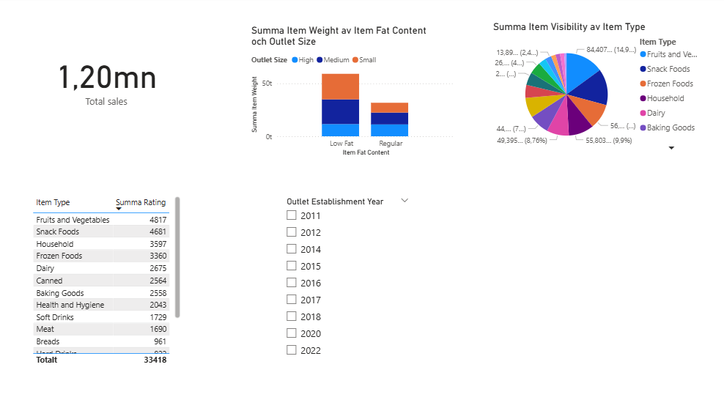
Figure 4 Grocery Sales Fat Content
Figure 4’s dashboard represents a better understanding of how sales can differentiate if the item's fat content is low fat or regular. To show this, there is a clustered vertical bar chart illustrating both low fat and regular next to each other, per item type. For further clarification, there is a donut chart showing the percentage of an item type’s fat content. There is an option to select each item type for comparison, but overall, with all item types included, one can see clearly from the donut chart that low-fat items have higher total sales. The donut chart provides a faster and clearer view of the differences between low and regular fat content. Another interesting aspect is the comparison of different outlet types, showing their total sales and how much of this comes from low-fat or regular items. There is also a slicer where one can select the outlet type, and the item type within that outlet, to gain a clearer view of sales inside the outlet. Lastly, an overview of the sales for each item type and their total sales was created, showcased with the help of a matrix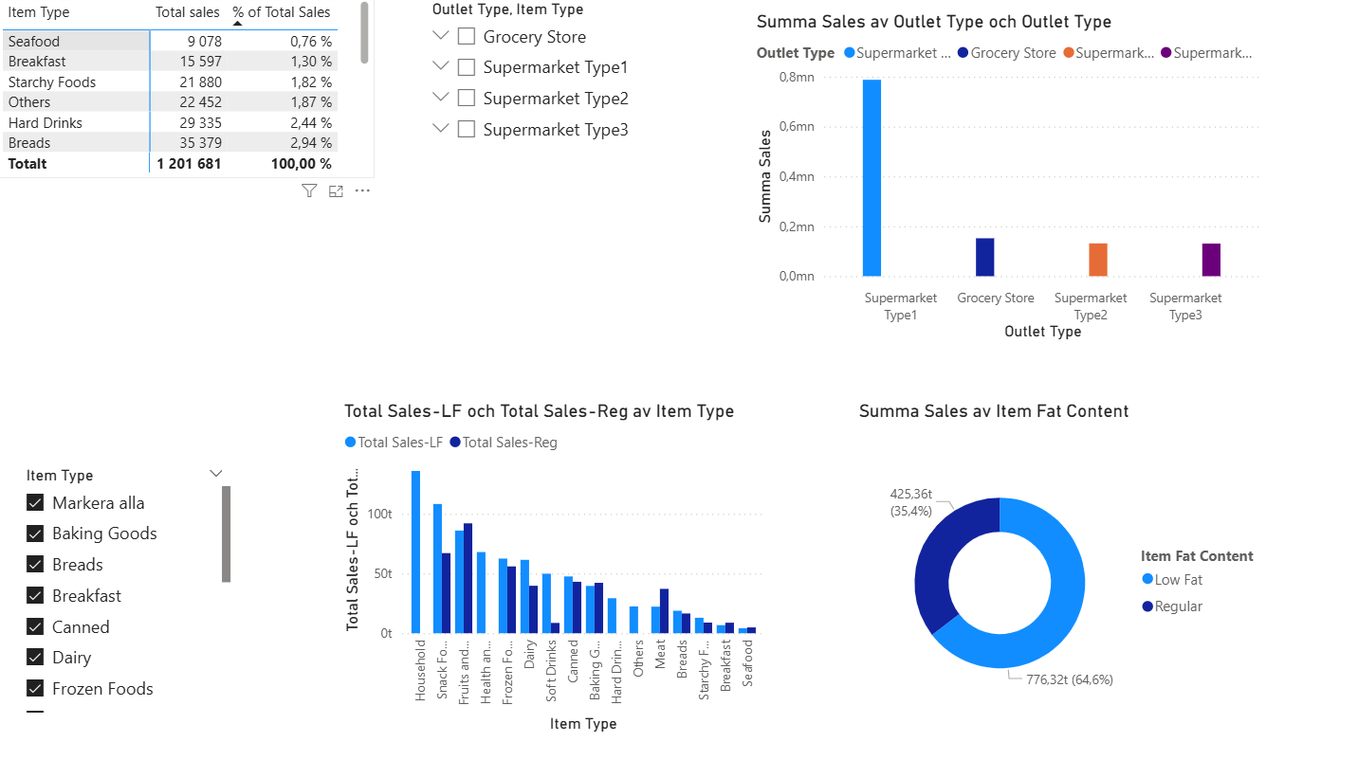.
Figure 5 retail item visibility
Figure 5’s dashboard provides an overview of item performance and sales distribution across different product categories. It highlights the relationship between item fat content and visibility by outlet size, shows the distribution of items by type, and summarizes total sales by item category. Key metrics such as total item visibility are included to give a quick shot of overall product exposure and performance.
There is a Bar chart that shows item visibility by item fat content och outlet size. This chart compares the total item visibility for products with different fat content (Low fat, Regular) Across outlet sizes (Small, Medium, Large). It helps identify how product visibility varies depending on both nutritional category and store size, showing that larger outlets generally provide higher visibility for items.
The Pie chart shows the distribution of items across different item types based on their fat content. It provides an overview of how product categories such as fruits, snacks, dairy, and frozen foods are proportionally represented in the dataset.
Another chart is the table that highlights the total sales by item type. It presents the sum of sales for each item category, allowing easy comparisons between product types. It highlights which categories generate the highest total sales, with fruit, vegetables, and snack food appearing as top performing segments.
The KPI card displays the overall item visibility value, summarizing the total exposure of all products across outlets.
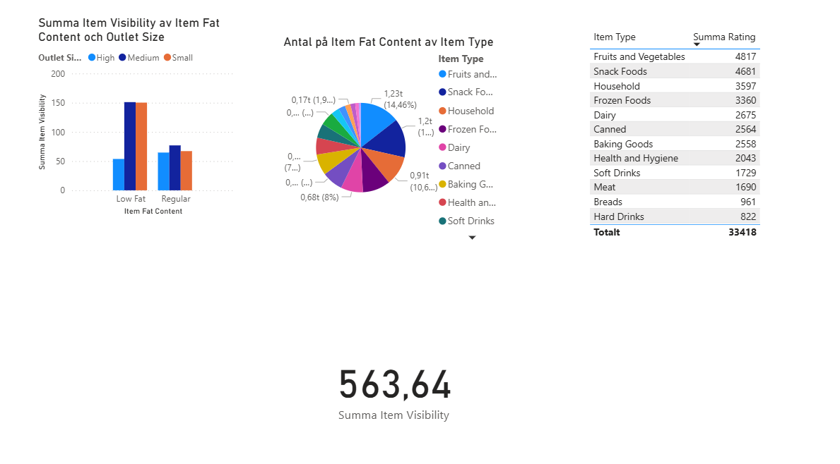

Figure 6 overall ratings review
This dashboard focuses primarily on the ‘Ratings’ aspect of the dataset. This is very important information that allows us to track the average rating of each product (see Average Ratings), giving us an idea of what customers think of the overall products available in all stores.
It is also possible to see the highest and lowest rated products, sort them by year of release, category and type of retail outlet, in order to keep track of their performance and compare them with each other to check whether the ratings are in line with the planned objectives, or, if not, to put action plans in place to help them achieve this objective.
I’ve chosen colours that are fairly logical (green for positive aspects and red for areas for improvement) to make it easy to identify the current status on the various graphs, so that the situation can be quickly analysed and critical situations identified, while enhancing overall understanding of the dashboard.
We can see that the overwhelming majority of products have a rating of 4/5, with an average of 3.92/5. As excellent as these figures may seem, they have no real meaning given the lack of current objectives for product ratings.

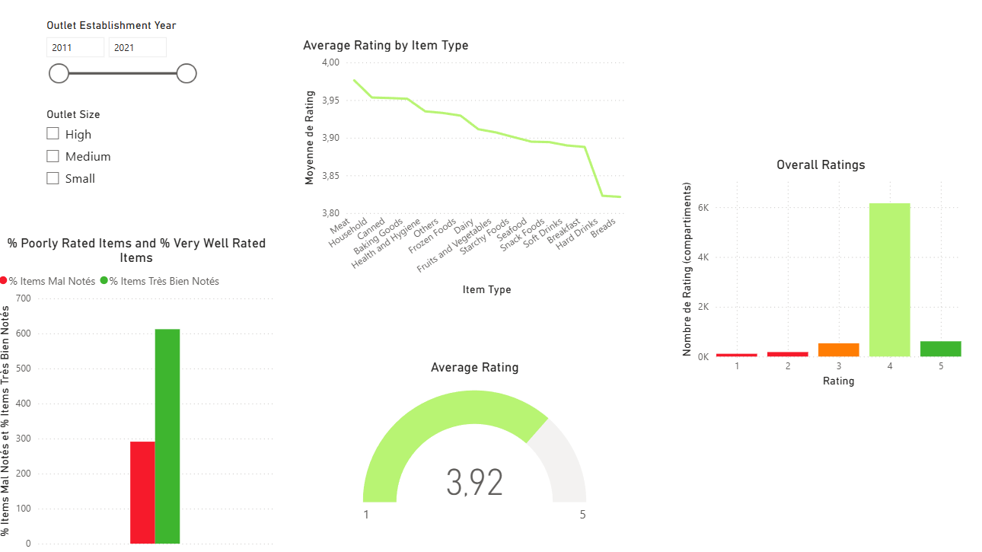

Challenges and Learnings

4.1 Data cleaning, standardization and dashboard development
During this project we faced several challenges that helped us understand both the data and the tools more deeply. One of the biggest challenges was to interpret and understand what the dataset actually showed, such as what the values, categories and variables meant. Before building any visualizations, it was important to spend time exploring the data and deciding which parts were most relevant for the analysis. A further challenge during the project was creating KPIs without clear targets, which made the KPI tables harder to interpret.
Another challenge was cleaning and preparing the data before building the dashboard. After importing the Excel file into Power BI, we noticed mixed formatting and categories that meant the same thing however they were written differently. A clear example was the column with the Item Fat Content, which includes labels like “low fat”, “LF”, and “Low Fat”. To correct this, we used Power Query to standardize the different labels. Without correcting the labels, the dashboard visual would have been misleading, causing the patterns we found not to be trustworthy.
We also learned how to choose appropriate visualizations. We experimented with different visuals such as bar charts, pie charts, cards and slicers in order to find which visuals best explained the patterns in the data. The design part was about making the dashboards easy to read and follow, avoiding too much information and placing the visuals in a logical order.

4.2 Technical challenges encountered during the Project
One technical problem that we had to overcome was interpreting the dataset. Several columns had unclear meaning, requiring us to explore the data thoroughly before moving into visualizations. Small inconsistencies, such as spelling differences or mixed categories, reinforced the importance of proper data cleaning and standardization. Power Query proved valuable for simplifying these tasks and preparing the dataset efficiently. The word “null” popped up several times throughout the data, which made the file hard to handle.

4.3 Key learnings from working with Power BI
A significant learning outcome from using Power BI is the importance of proper data preparation. The data transformation component provides tools to clean, filter, merge and reshape datasets and Power Query highlighted how raw data often contains inconsistencies, missing values and structural issues. An important lesson was how Power BI can streamline reporting processes. By building dashboards for real data, it became possible to explore performance indicators relating to sales, operations, and customer behavior.

Conclusion

This project to analyze food sales using Power BI highlighted the importance of product and point-of-sale factors in overall commercial performance. Using a rich dataset incorporating information on product characteristics (type, weight, fat content, visibility, rating) and stores (size, type, location, year of establishment), the main objective was to understand which factors most influence sales and how this information can support better decision-making.

Extensive data preparation and cleaning proved essential. Standardising categories, particularly for fat content, and processing missing values for item weight ensured the reliability of the analyses. Attempts at star schema modelling also contributed to a better understanding of the data structure, even though the initial table proved sufficient to meet the analytical objectives.
Thanks to the creation of DAX measures and the use of appropriate visualisations (KPI cards, matrices, bar charts, pie charts and slicers), the dashboards provided a clear and interactive overview of the results. Analyses showed that certain product categories, particularly fruit and vegetables and snacks, generate a significant share of sales, while medium-sized stores and type 1 supermarkets perform best. In addition, low-fat products generally record higher sales, highlighting a potential trend among consumers towards choices perceived as healthier.
The study also highlighted the key role of product visibility, which is strongly correlated with customer satisfaction and high ratings. The rating dashboards revealed an overall positive assessment of the products, although the absence of benchmarks limits the strategic interpretation of these indicators
Finally, this project was a major learning experience, both technically and methodologically. It highlighted the importance of data quality, the relevant choice of visualizations, and Power BI's ability to transform raw data into actionable insights. In conclusion, this analysis provides a solid basis for improving inventory management, optimizing shelf space and guiding commercial decisions, while illustrating the potential of Power BI as a decision-making tool.

